**CS606 Assignment #1 spring 2023**

Name: Abdul Rehman.

VU-ID: BC220424444.

**Question # 1: Marks: 10**

Draw a Transition Graph with the help of following Transition Table of a typical NFA.

|  |  |  |  |
| --- | --- | --- | --- |
|  | **a** | **b** | **ε** |
| **0** | 0, 1 | 4 |  |
| **1** | 2 | 0 | 3, 4 |
| **2** | 3 | 1, 2 |  |
| **3** | 3, 4 | 2 |  |
| **4** | 0 | 3, 4 |  |

Table: Transition Table of a typical NFA.

**Note:**

In transition table, ε represents epsilon (*i.e., empty / null input*).

For drawing purpose, you can use any drawing tool (*e.g., MS Word, MS Visio and Paint etc.*).

**Solution:**

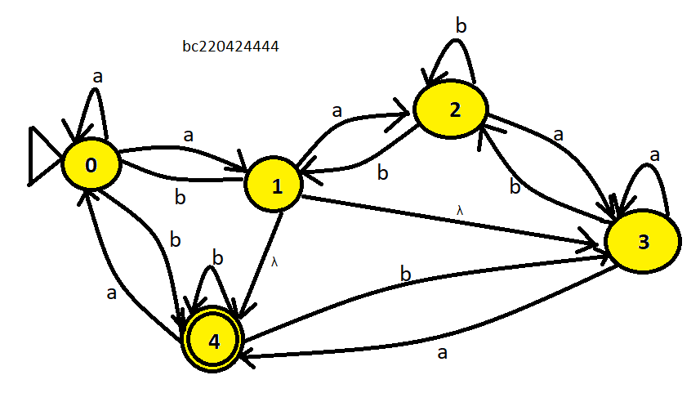

**Question # 2: Marks: 10**

Construct a Transition Table with the help of following Transition Graph of a typical NFA.

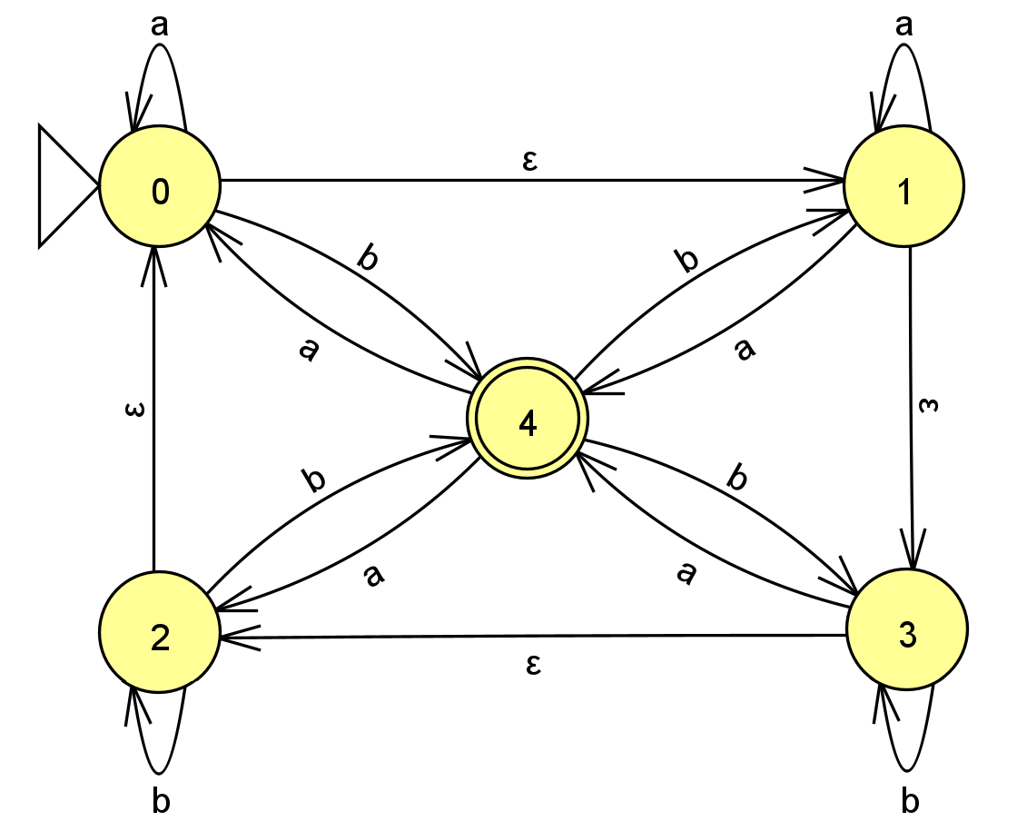

Fig. Transition Graph of a typical NFA

**Note:** In transition graph, ε represents epsilon (*i.e., empty / null input*).

**Solution:**

Transition Table:

|  |  |  |  |
| --- | --- | --- | --- |
|  | **a** | **b** | **ε** |
| **0** | 0 | 4 | 1 |
| **1** | 1,4 |  | 3 |
| **2** |  | 2,4 | 0 |
| **3** | 4 | 3 | 2 |
| **4** | 0,2 | 1,3 |  |

Table: Transition Table of a typical NFA.